Preparing a Data Frame: Data Cleaning and K-Means clustering

By

Sapphira Frankl-Slater

Submitted to

The University of Liverpool

Computer Science MSc

CSCK503 Machine Learning in Practice January 2025 A

Word Count: 497

09/03/2025

Preparing a Data Frame: Data Cleaning and K-Means clustering

Submitted to

The University of Liverpool

Word Count: 497

09/03/2025

TABLE OF CONTENTS

Page

Chapter 1. Introduction 2

Data Quality 3

Clustering 7

Conclusions 12

REFERENCES 13

Introduction

This report documents improving the data quality of a dataset file. The aim was to clean the CSV file to prepare it for a Machine Learning (ML) system, as bad quality data could result in unreliable decision making. This was done using K-Means clustering, an unsupervised ML technique, that finds patterns by grouping data points into clusters based on similarities of the mean without using labelled data (University of Liverpool, n.d.).

Data Quality
The data quality of the data set needed amending; this is documented below.
Missing data was replaced with placeholders:
Columns were standardised by removing whitespace, varying uppercase characters and duplicated rows. The ID column was changed to string format, to standardise columns before clustering (in hindsight, unnecessary) and the date was converted to datetime format (Pandas, n.d.).
Columns were standardised by removing whitespace, varying uppercase characters and duplicated rows. The ID column was changed to string format, to standardise columns before clustering (in hindsight, unnecessary). The date was converted to datetime format (Pandas, n.d.).
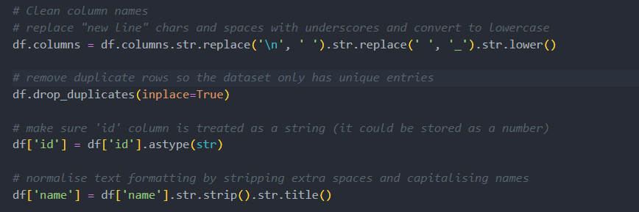
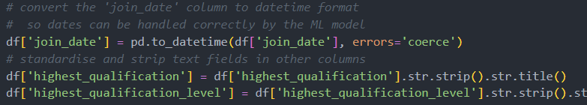

An overloaded column contained multiple values, so was normalised. As commented in the code, this section used regular expressions that need refining to accurately separate the data within the field. Currently, it is separating data based on two or more consecutive spaces between values, which works for some data (Pandas, n.d; Python Software Foundation, 2025).
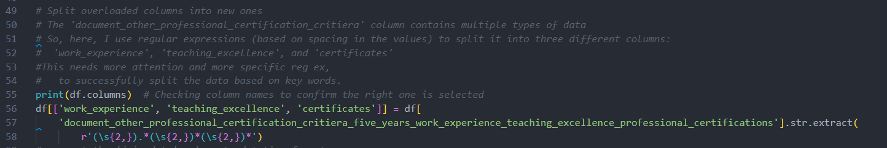
Updated CSV file and table on Jupyter:
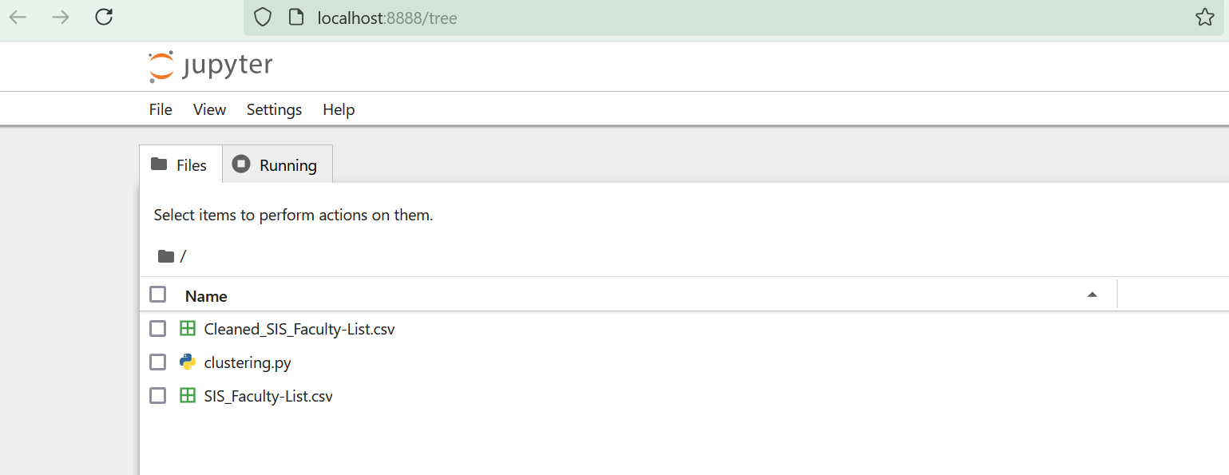
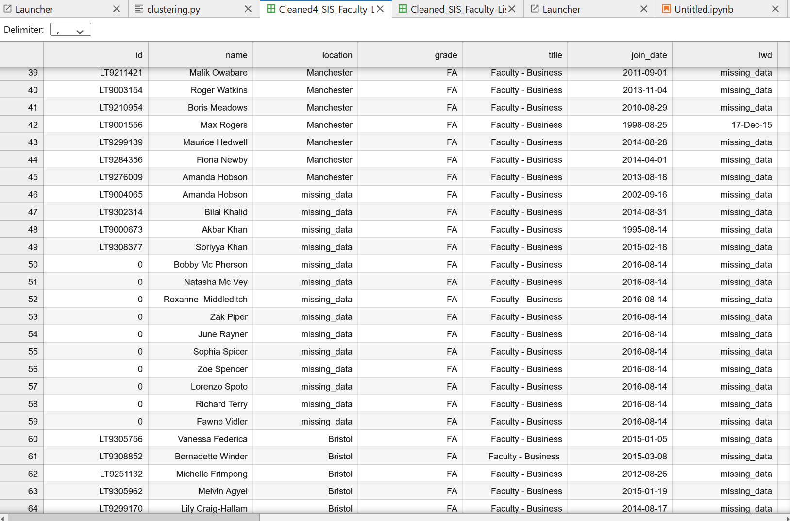
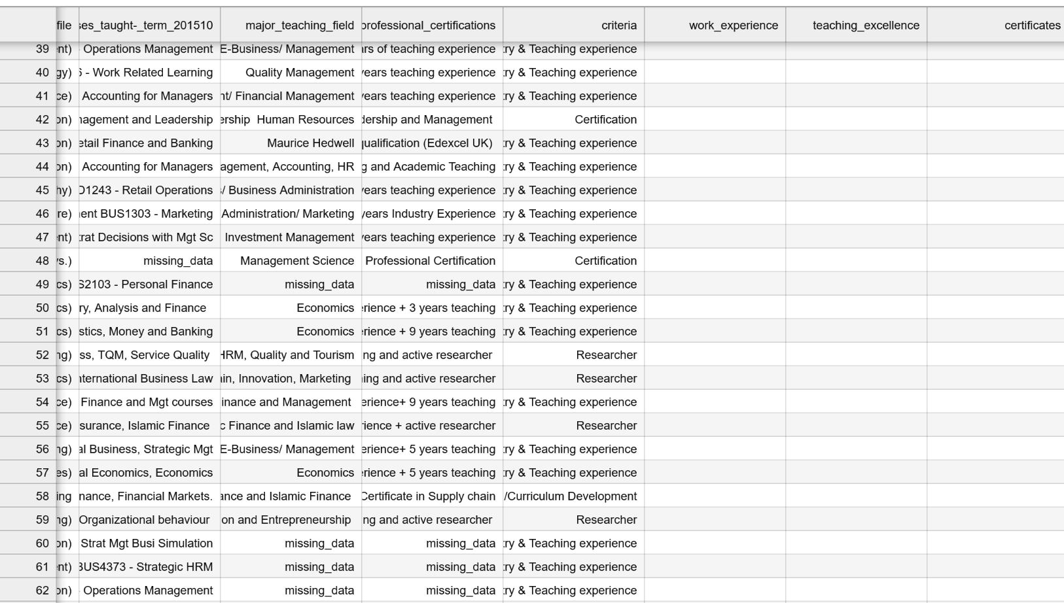
SkiLearn’s encoder changed the data to numeric for K-means clustering (Scikit-learn, n.d.b). Numpy’s column selection and Panda’s column filtering allowed for clustering numeric data (Pandas, n.d; NumPy, n.d.).

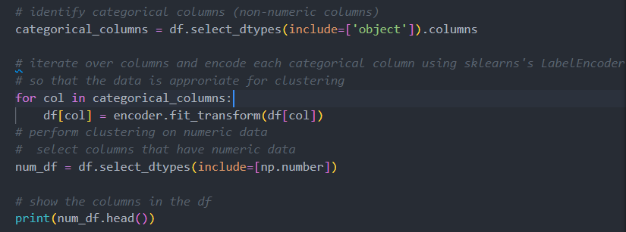
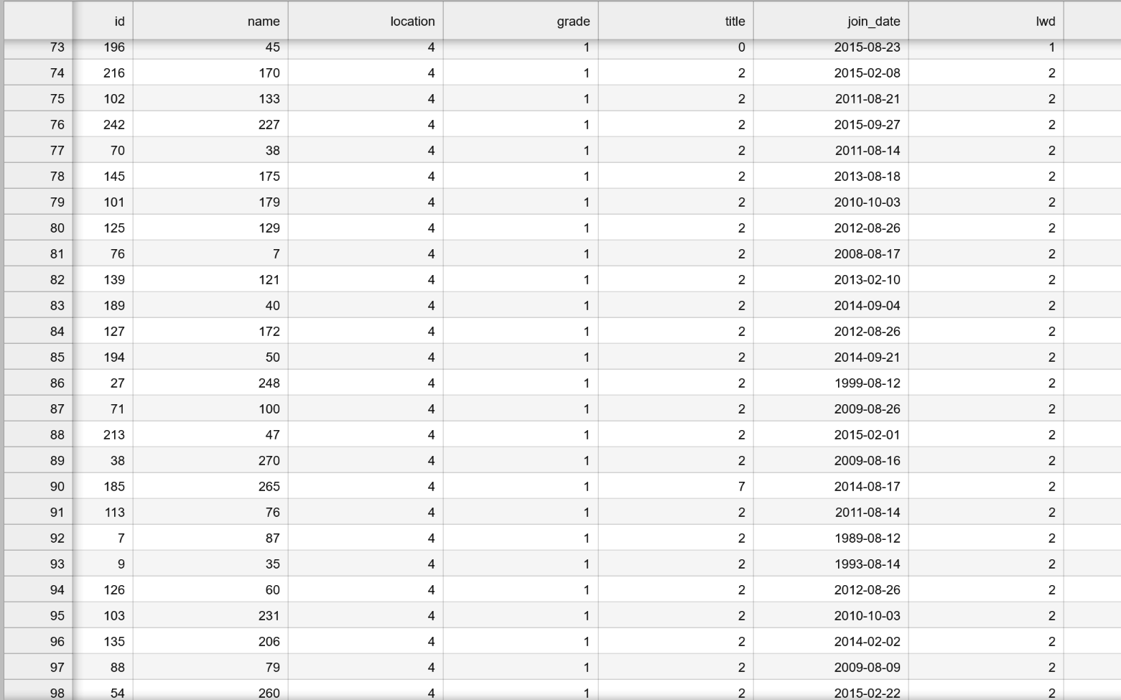

Clustering

The K-means algorithm categorised clusters into 4 and a new column was created showing which cluster each item belonged to:

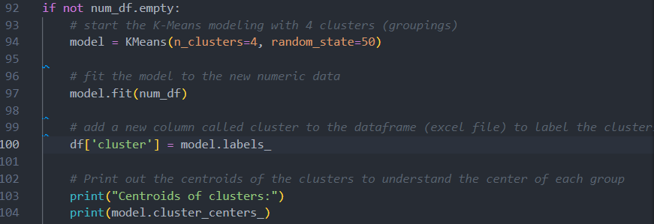
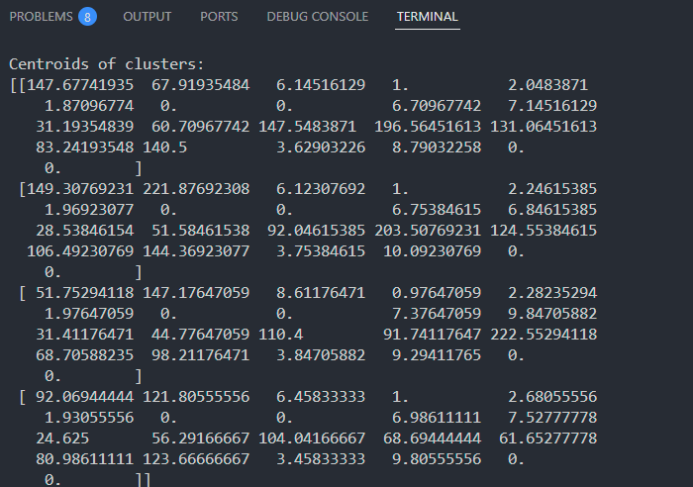
Figure: Centroids of clusters

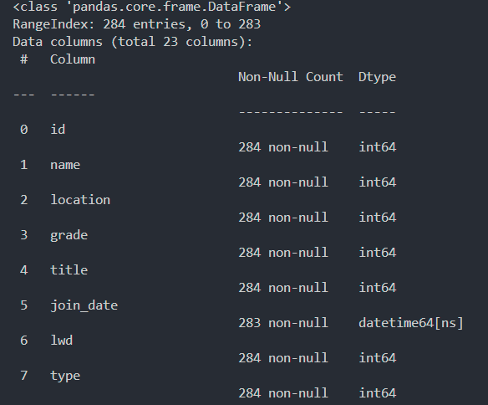

The results show the output of clustering. The centroids represent the mean of each feature for each cluster, making general group characteristics clear (Scikit-learn, n.d.). Each row represents a data point and columns express features (location, grade) These are numerical values now, encoded earlier to help with creating an inline clustering plotting diagram on Jupyter.

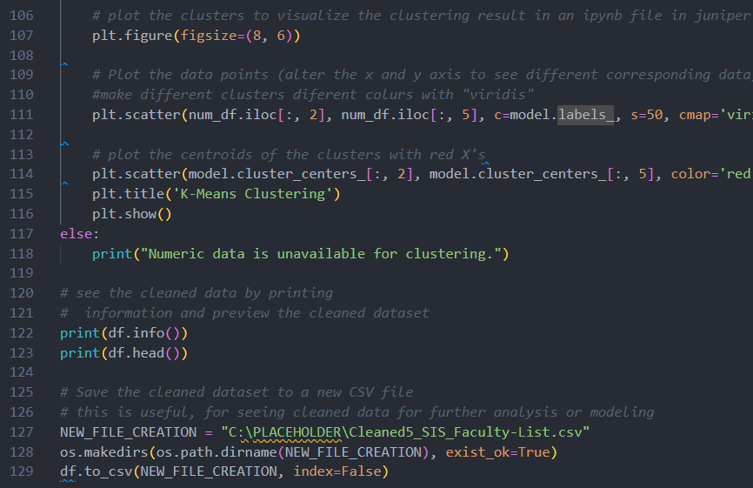

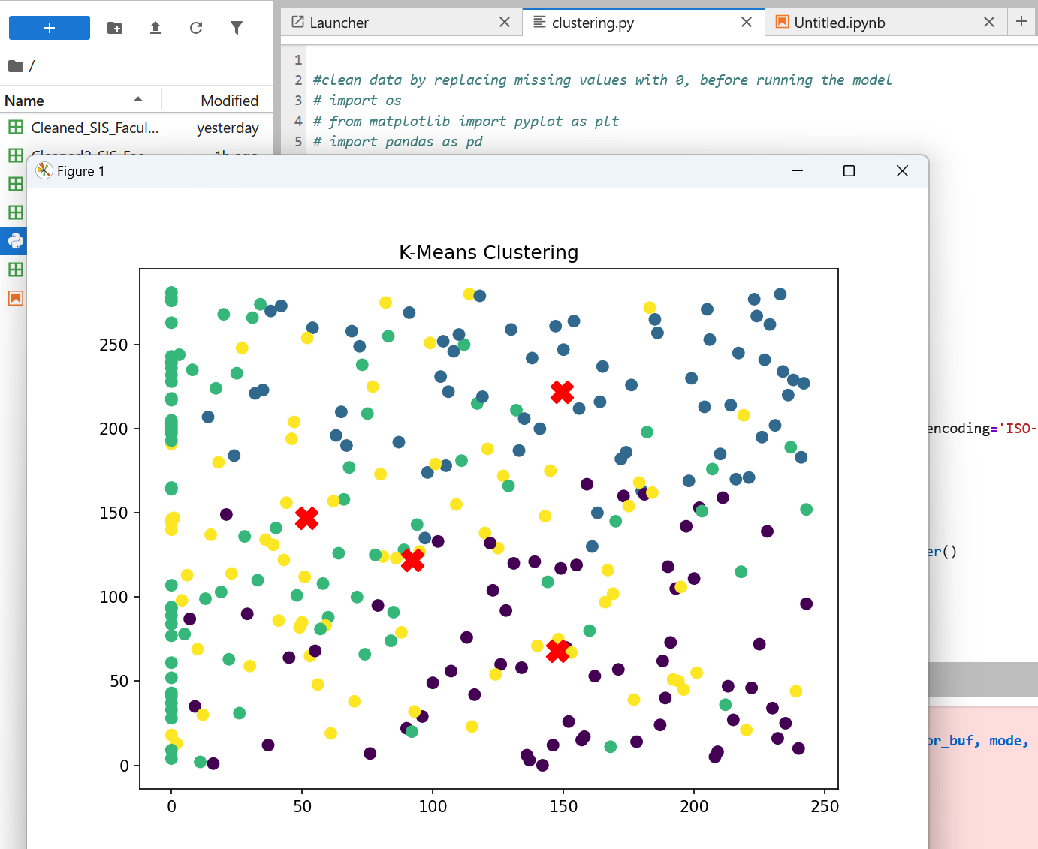
Graph 1: X (“ID”) Y (“name”)

“Graph 2” (below), has more meaning than graph 1, as data-points appear less, due to less variety in names and ID characters, than in locations/dates.

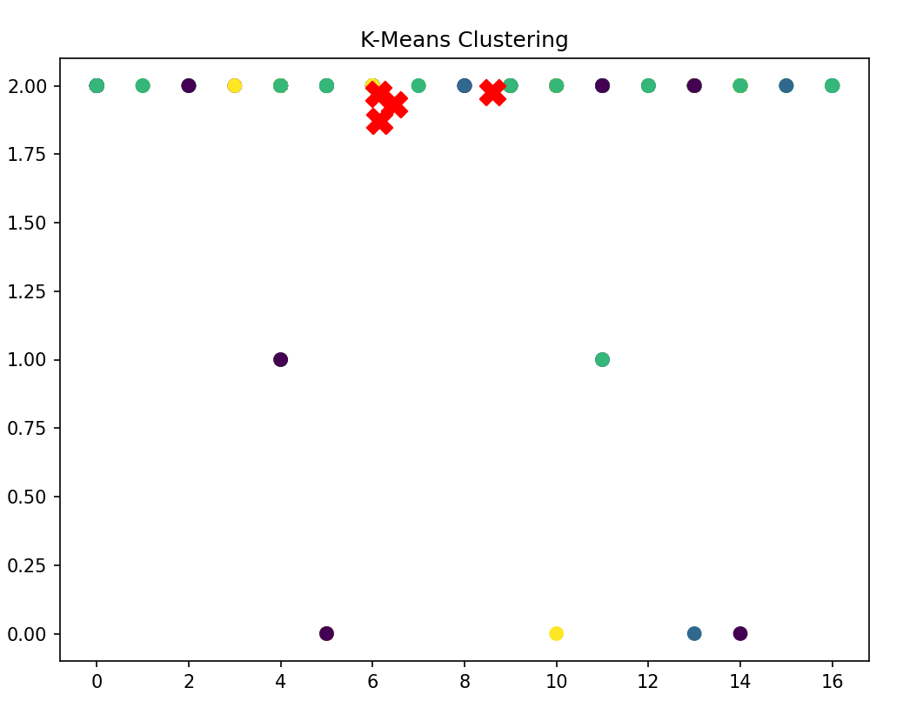
Graph 2: X (“location”) Y (“join date”)
In “Figure: Centroids of clusters” (p.8), centroids show the average values for each feature. The first centroid has a location of 6.1 (diverse locations), the join date is 28.5 (months since joining). Cluster 1 and 2 have similar locations and grades, however Cluster 2 has a higher name value (needing further analysis) and a lower join date (suggesting more recent joiners). Cluster 3 stands out with a higher location value. These insights are helpful for understanding user traits and making future decisions.

Conclusions

Although data was cleaned regarding missing values, standardisation, conversion and removal of duplicates, improvements should be made for accurate value separation and more meaningful values should be amended or excluded from the clustering, such as ID’s and Names.

REFERENCES

Matplotlib (n.d.) matplotlib. Available at: https://matplotlib.org/stable/api/matplotlib_configuration_api.html (Accessed: 28 February 2025).
NumPy (n.d.) Scalars. Available at: https://numpy.org/doc/stable/reference/arrays.scalars.html (Accessed: 28 February 2025).
Pandas (n.d.) API reference. Available at: https://pandas.pydata.org/pandas-docs/stable/reference/ (Accessed: 28 February 2025).
Python Software Foundation (2025) re — Regular expression operations. Available at: https://docs.python.org/3/library/re.html (Accessed: 28 February 2025).
Scikit-learn (n.d.) Clustering. Available at: https://scikit-learn.org/stable/modules/clustering.html#k-means (Accessed: 27 February 2025).
Scikit-learn (n.d.b) LabelEncoder. Available at: https://scikit-learn.org/stable/modules/generated/sklearn.preprocessing.LabelEncoder.html (Accessed: 27 February 2025).
University of Liverpool (n.d1.) Unsupervised Machine Learning Systems. Available at: https://liverpool-online-study.com/mod/scorm/player.php?a=15630&currentorg=articulate_rise&scoid=31297&sesskey=CBH1o9Khs8&display=popup&mode=normal (Accessed: 27 February 2025).

